Week 1

**Inventory table:**

1. Product Type
2. SKU
3. Availability
4. Number of products sold
5. Customer Demographics
6. Stock Levels
7. Lead times
8. Order quantities
9. Lead time
10. Revenue generated

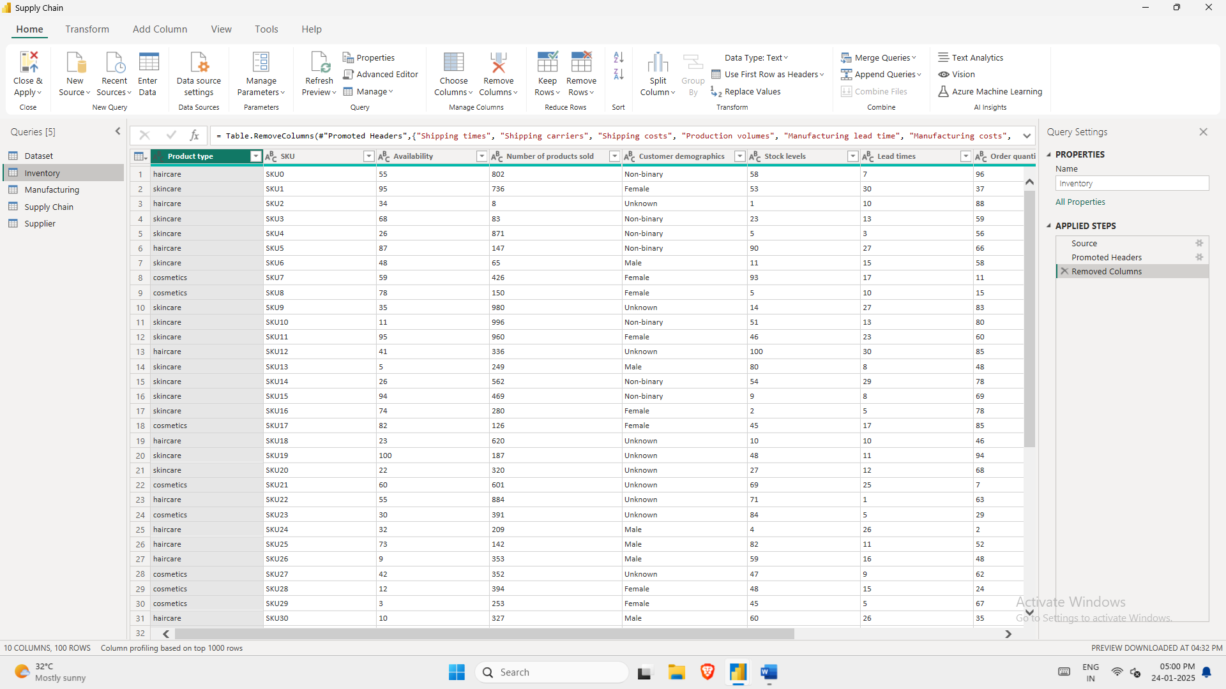

Manufacturing Table:

1. Product Type
2. SKU
3. Production Volumes
4. Manufacturing Lead Time
5. Manufacturing costs
6. Inspection results
7. Defect rates

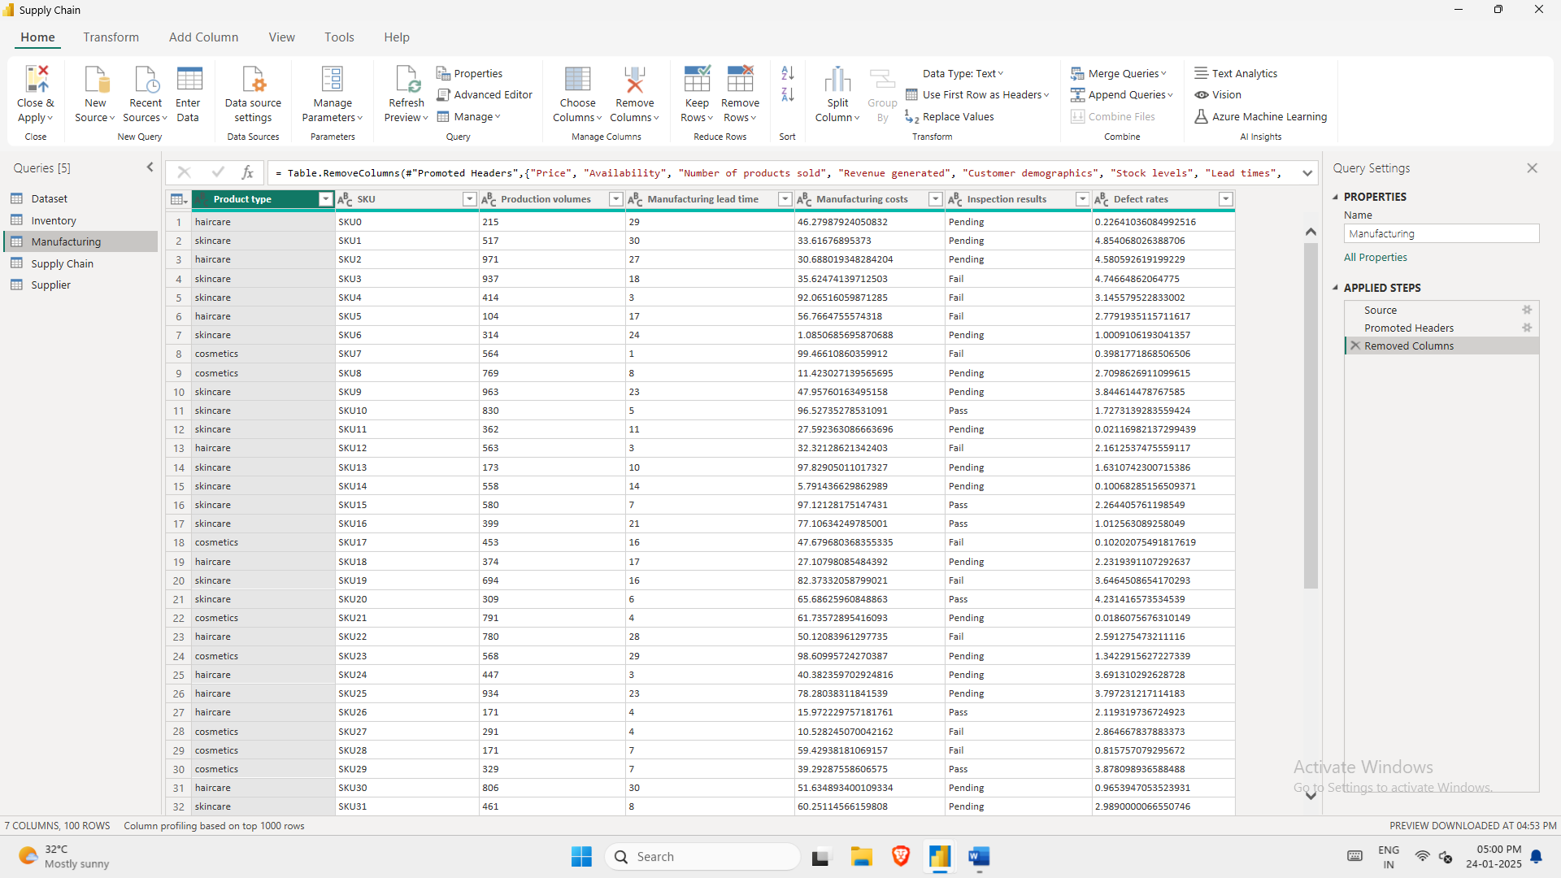

Supplier Table:

1. Supplier name
2. Location
3. Lead Time
4. Transportation modes
5. Routes

Supply Chain:

1. Product Type
2. SKU
3. Price
4. Availability
5. Number of products sold
6. Revenue generated
7. Customer Demographics
8. Stock Levels
9. Lead times
10. Order quantities
11. Shipping times
12. Shipping carriers
13. Shipping costs
14. Supplier name
15. Location
16. Lead time
17. Transportation modes
18. Routes

